**Experiments -1: Installation of GIMP AND BLENDER.**

Steps to install GIMP in Windows 10:

1. Open Any Web browser like Google, Firefox.
2. Search for “Gimp Download” or type gimp.org in url. Official Website of Gimp will be opened.

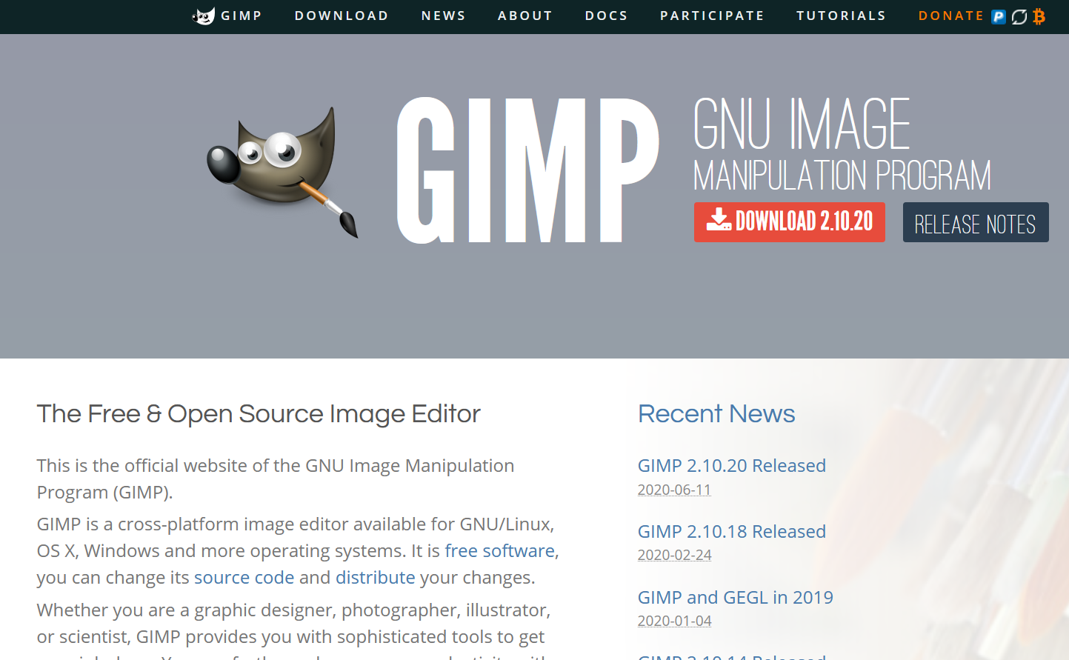

1. 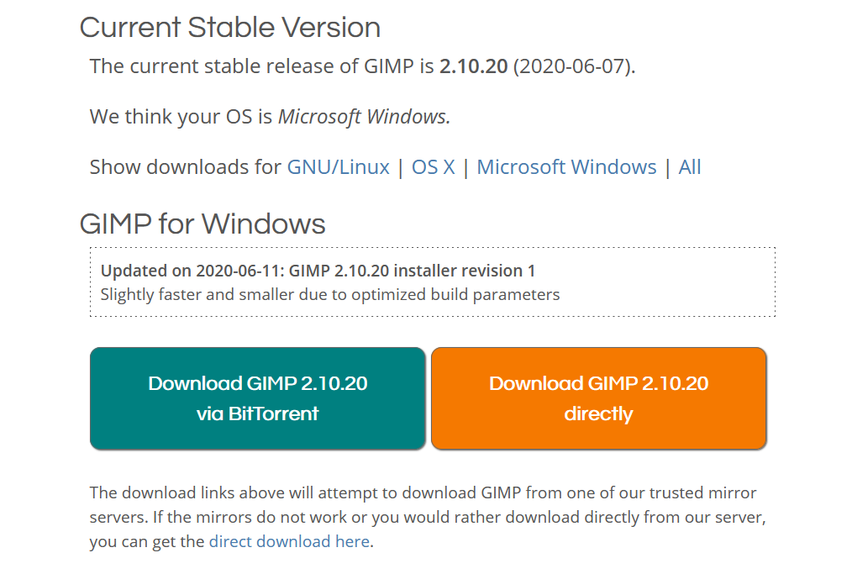Click on Download then select your system file matching with your system configuration and click on downloads.
2. After downloading the Gimp go to download folder. You can find the file their. Generally file is saved at Downloads/My Downloads folder.
3. Click on the downloaded file. Installation will automatically start. Leave all settings as default.
4. Once the installation is complete start GIMP. See this guide for tips on getting started.

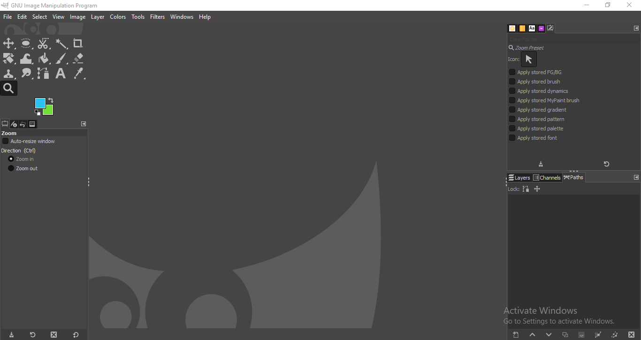

Steps to install Blender in Windows 10:

1. Open Any Web browser like Google, Firefox.
2. Search for “Blender Download” or type https://www.blender.org/. in url. Official Website of Blender will be opened.

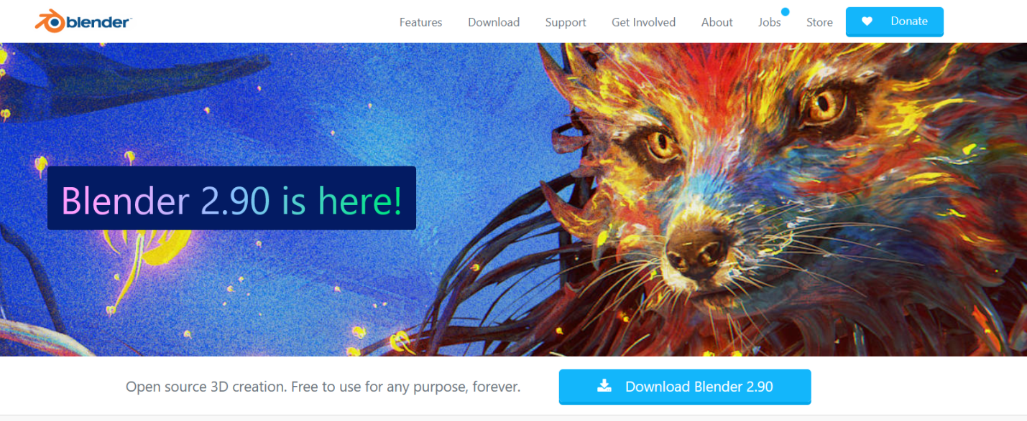

1. Click on Download then select your system file matching with your system configuration and click on downloads.

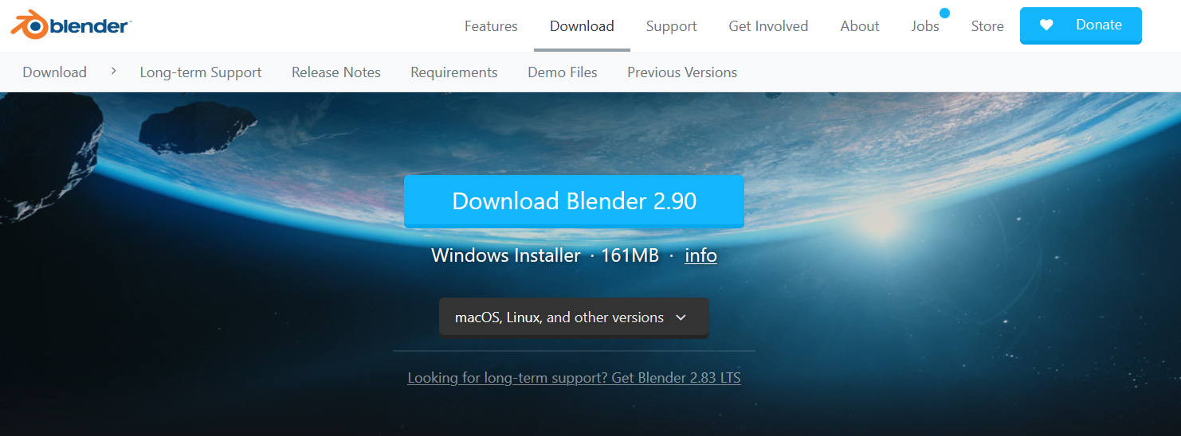

1. After downloading the Blender file go to download folder. You can find the file their. Generally file is saved at Downloads/My Downloads folder.
2. Click on the downloaded file. Installation will start. Leave all settings as default.
3. 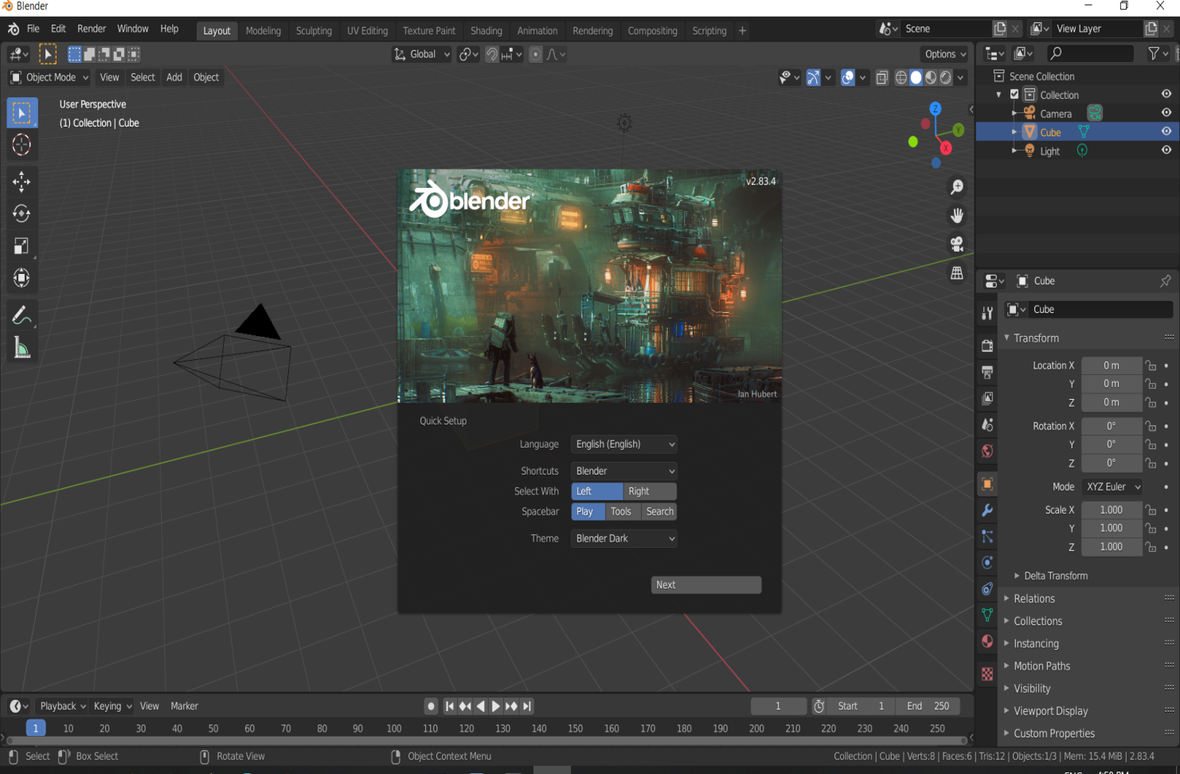Once the installation is complete start Blender. See this guide for tips on getting started.